**Name:** Gunjan Jhawar

**Subject code:** EE 511

Simulation of Scholastic System

**USCID:** 1857534264

**Project: 6**

**Aim:**

Let  be iid exponentially distributed random variables with . Define the random variable . The distribution of  is called an Erlang-*n* distribution.

The pdf for  can be shown to be:



And the CDF can be expressed as:

 (defining  for convenience)

In this project, you are asked to generate samples of for  by three different methods

1. By means of a simulation experiment, generate values for  and use them to generate a series of samples for . Compute the sample mean and sample variance for  and compare to the analytical value. Also plot a histogram approximation of the probability density function,.
2. A more (computationally) efficient way to generate samples for  uses:  
      
   Where . (Why does this work?) Use this approach to generate a series of samples for  and compute mean and sample variance, and compare to part A
3. Compare the time it takes to generate (10,000, say) samples of  using these 3 approaches.

**Software Used:**

MATLAB

**Theory:**

The **Erlang distribution** (sometimes called the Erlang-k distribution) was developed by A.K. Erlang to find the number of phone calls which can be made simultaneously to switching station operators.

Erlang’s distribution has since been expanded for use in queuing theory, the mathematical study of waiting in lines. It is also used in stochastic processes and in mathematical biology.

The Erlang distribution is a specific case of the Gamma distribution. It is defined by two parameters, k and &u, where:

* k is the shape parameter. This must be a positive integer (an integer is a whole number without a fractional part). In the Gamma distribution, k can be any real number, including fractions.
* μ is the scale parameter. Must be a positive real number (a real number is any number found on the number line, including fractions).

The Erlang distribution with shape parameter {\displaystyle k=1}k k simplifies to the exponential distribution. [1]

## **Statistics of the Erlang Distribution**

* Mean: k / λ.
* Variance: k / λ2. [2]

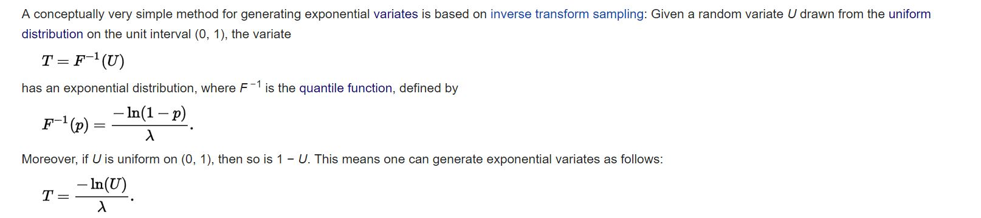

Derivation of exp from U [3]

**Procedure:**

1. Using the above knowledge that taking inverse of x = Uniform Distribution from [0,1] using pseudo random number generator gives back y which belongs to an exponential distribution.
2. Generating pseudo random number using rand() function in MATLAB. It will be [100000,5] matrix, 5 representing the number of samples for every X(i) and 10,000 representing the number of i.
3. Assigning lambda value as 1.
4. Using the function ‘expinv’ to take the inverse of the uniform random distribution. The resultant will be uniform distribution X.
5. Defining S which is the sum of iid exponentially random variables also called Erlang Distribution. Summing all random variables X along the column.
6. Using function ‘mean’ and ‘var’ to compute mean and variance of S.
7. The second one is simplification of the first one as explained above in Theory.
8. Generating pseudo random number using rand() function in MATLAB. It will be [100000,5] matrix, 5 representing the number of samples for every X(i) and 10,000 representing the number of i.
9. Assigning lambda value as 1.
10. Using the formula – (log (uniform distribution))/ lambda to compute the exponential distribution X.
11. Defining S which is the sum of iid exponentially random variables also called Erlang Distribution. Summing all random variables along the column.
12. Using function ‘mean’ and ‘var’ to compute mean and variance of S.

**Result:**

**Part A)**





**n = 5** **n = 5**

**Part B)**





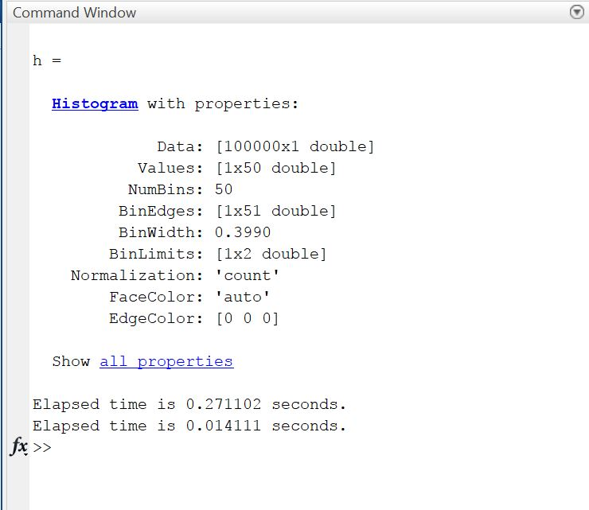

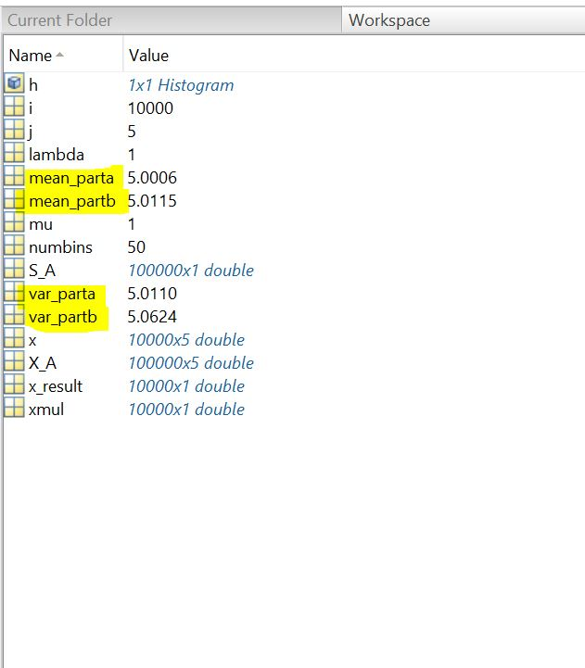

**Observation and Analysis:**

1. We observe that the mean is 5.0006 for part A.

Thus, comparing with the analytical result means k/ (lambda) which for our parameters where k = 5 and lambda = 1.

**Mean = 5**

So, simulation gives us an approximate result

1. We observe that the variance from part A is 5.0110. Thus, comparing by the analytical result which gives variance to be k/(lambda)^2.

**Variance = 5**

So, our simulation method gives us an approximate result.

1. We observe that for part B, we get mean as 5.0015 and variance as 5.0624 which are very close to the analytical result.

**Mean = 5**

**Variance = 5**

1. When we compare the time taken by Part A and Part B, we observe that Part B takes very less time as compared to part A. Part A takes 0.271102 seconds as compared to part B which takes just 0.01411 seconds. So, **second method is more efficient than the first one**.

**Conclusion:**

Part B is computationally more efficient as compared to Part A (simulation method).

**Reference:**

[1] http://www.statisticshowto.com/erlang-distribution/

[2] http://mathworld.wolfram.com/ErlangDistribution.html

[3] https://en.wikipedia.org/wiki/Erlang_distribution